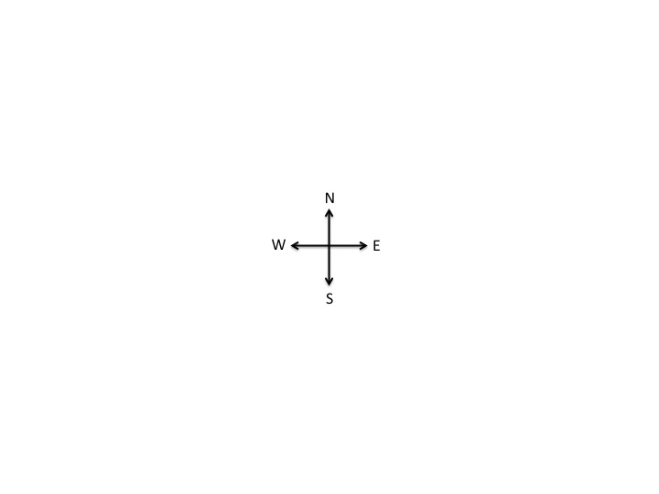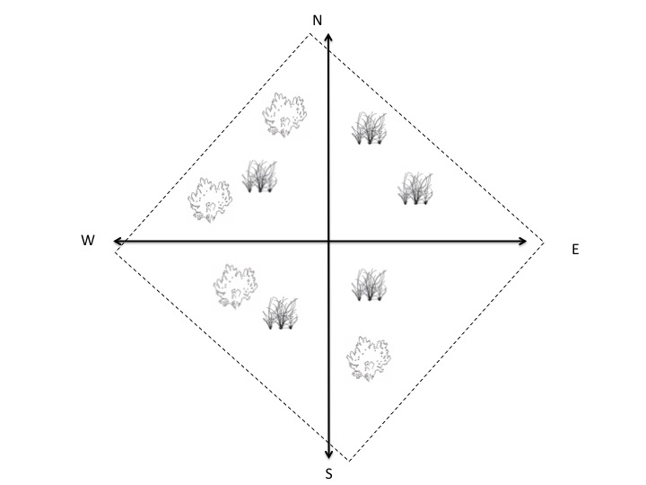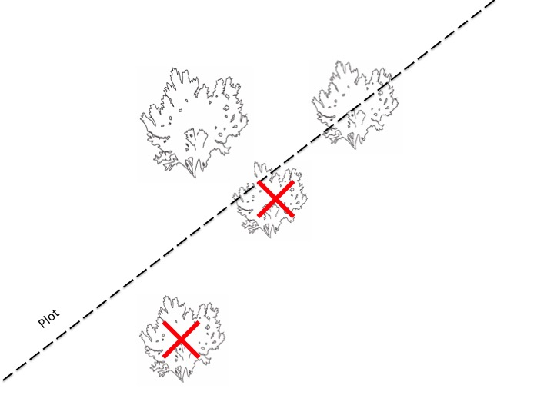

CUT TO: Show a close-up of one of the sides of the plot. This will show how to select if a plant on the edge is within or outside of the plot boundaries. If a plant is at least halfway in the plot, it is to be counted.

FADE TO: A person will begin walking and collecting data in the plot.

OPEN TO: The central cross will appear. From each direction, the arrows will extend to 25m. A dashed line will form around the entire plot, marking the plot.